Query Folding and Native Query

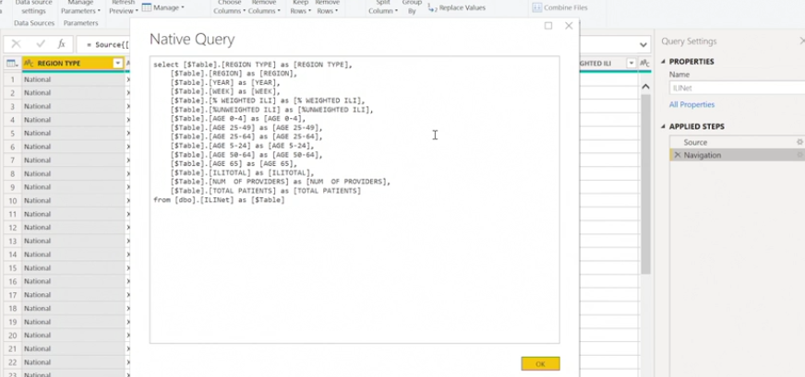

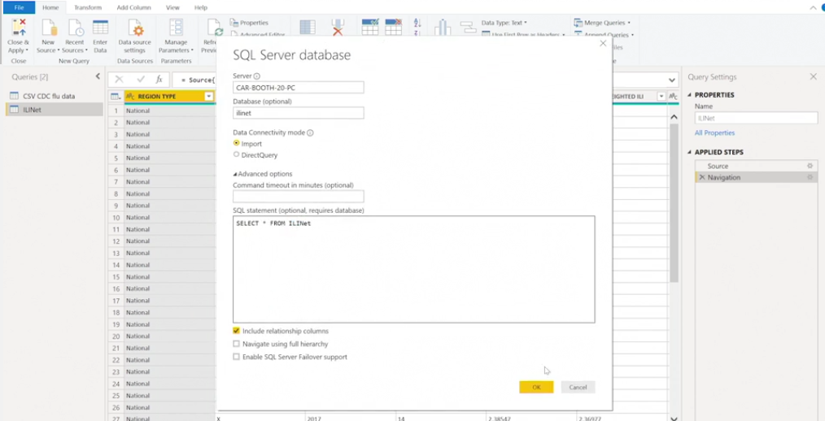

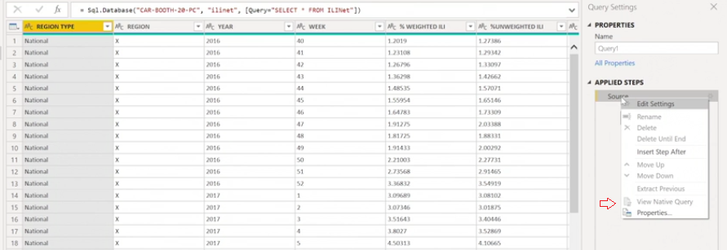

Connecting with Rest API

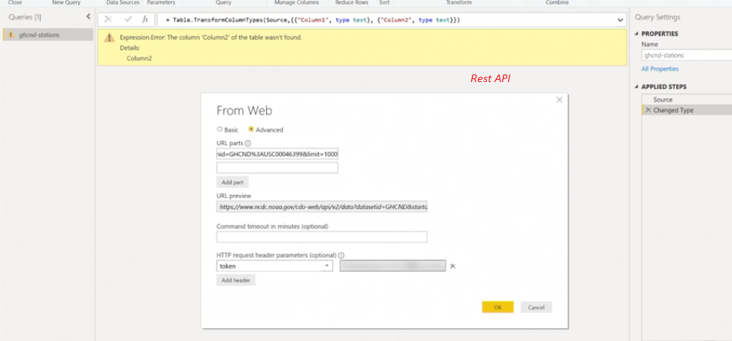

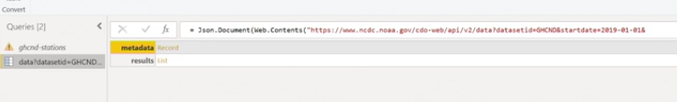

The GET request in a REST API connection allows you to do what?

It is an HTTP request that allows you to query your data through the REST API architecture.

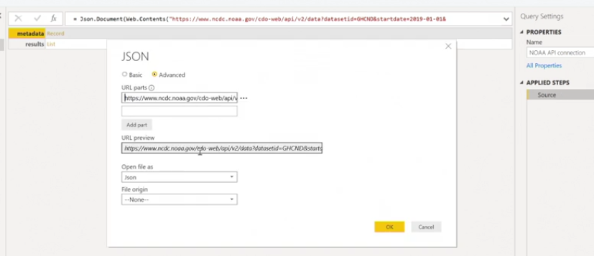

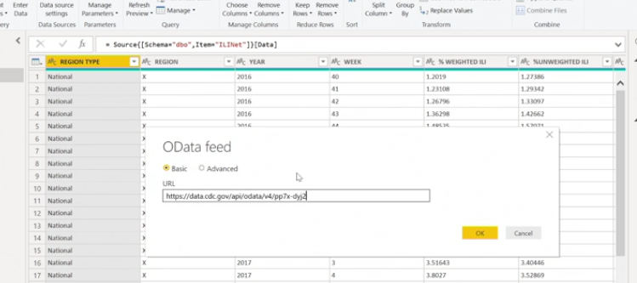

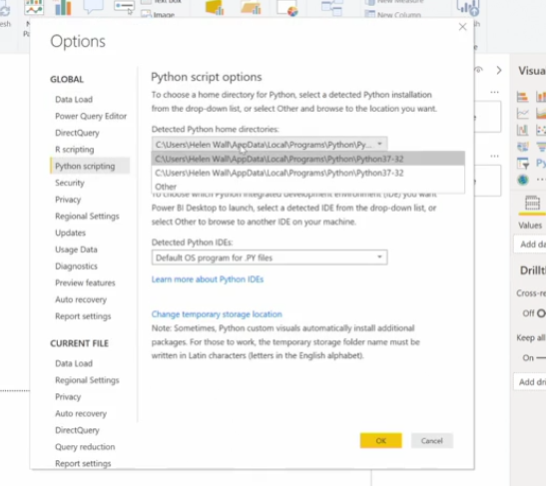

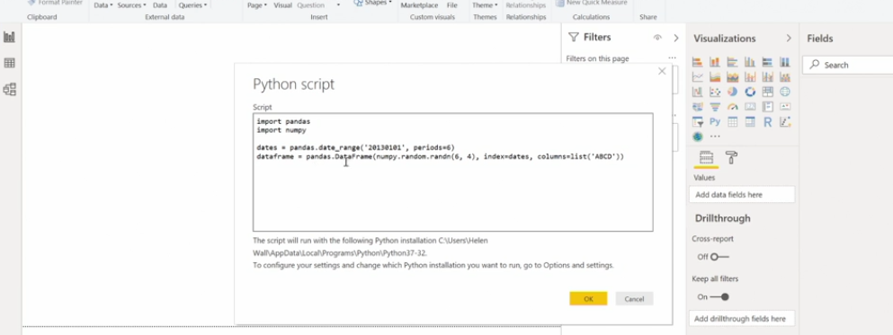

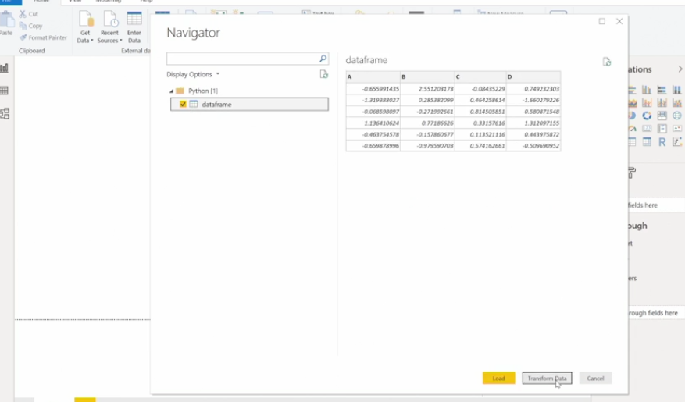

**Data Transformation : Cleaning**

**Leveraging Metadata**

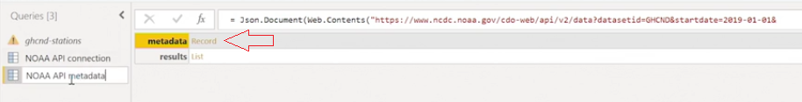

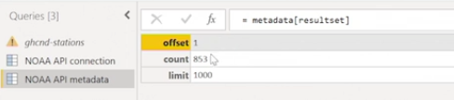

**Split column**

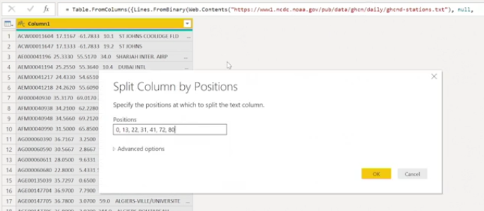

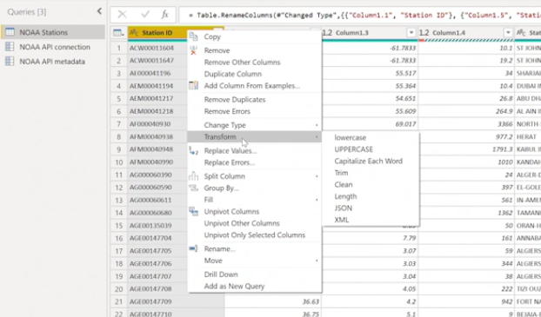

Transforming numeric Fields: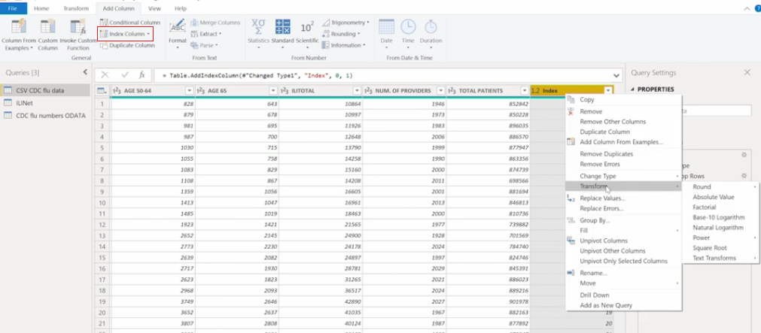

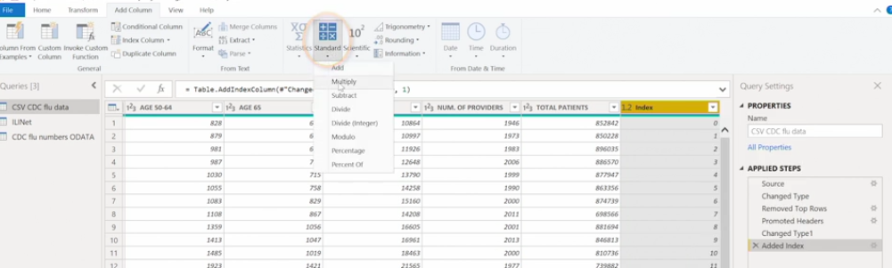

Removing / Replacing Error: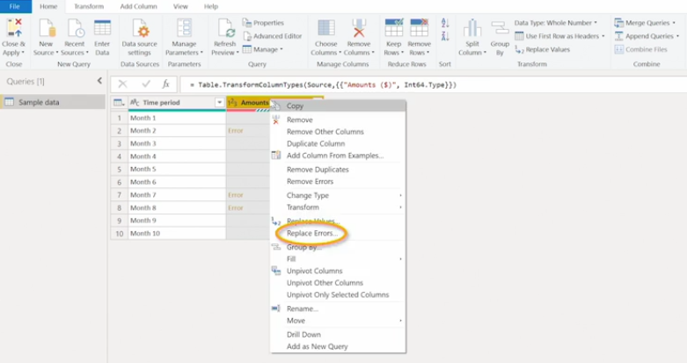

Remove Duplicate:

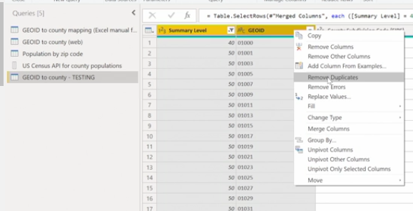

**Data Transformation : Integration**

Power Query Objects:

* tables
* Lists - column in table
* Records - row in a table
* Values
* Binaries
* Functions
* Errors
* parameters

Table

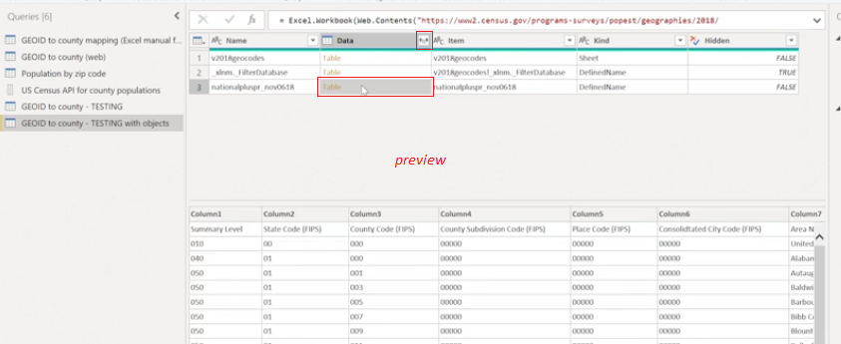

List

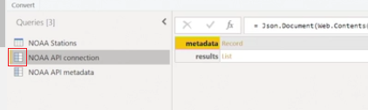

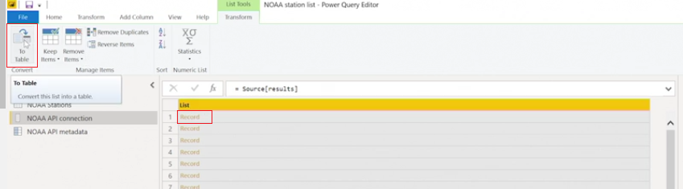

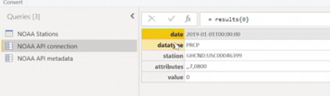

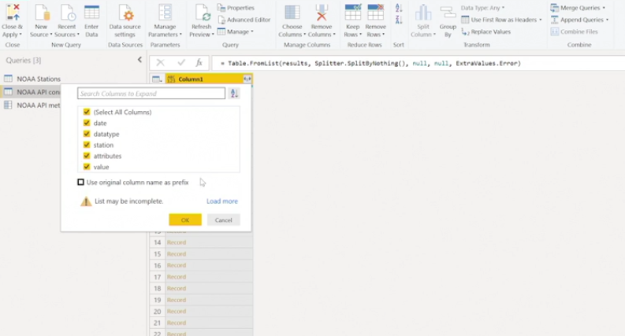

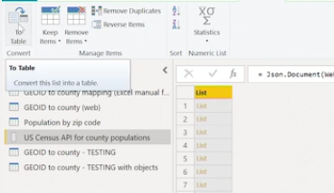

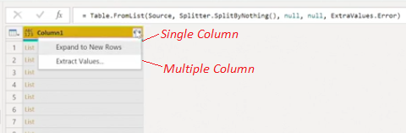

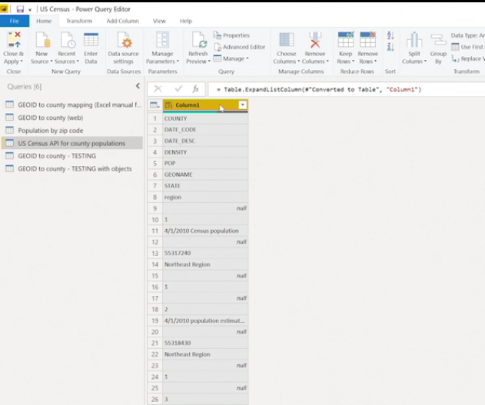

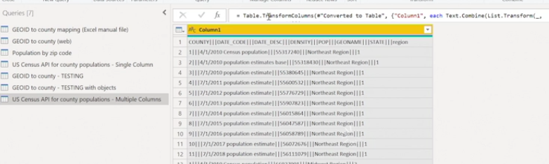

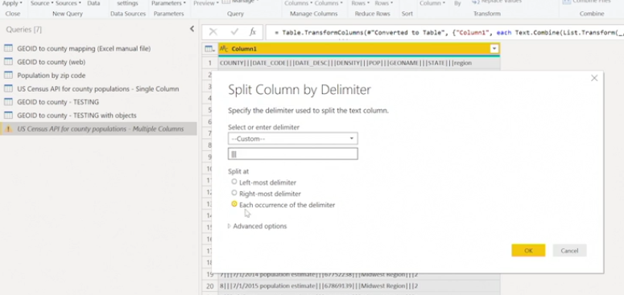

Binary Objects

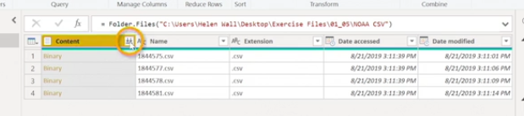

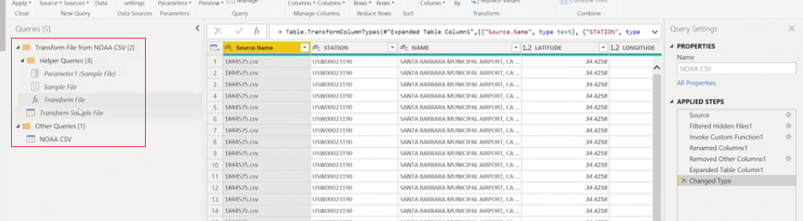

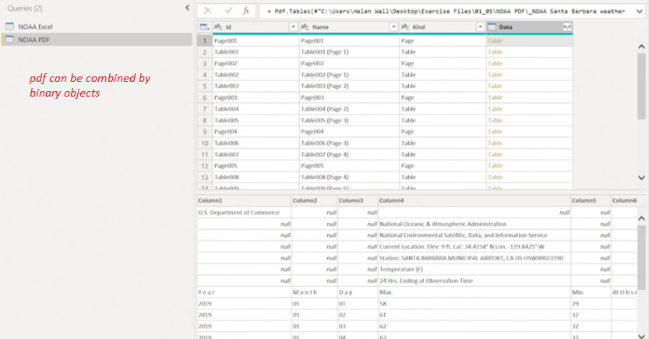

Grouping Data / Pivoting

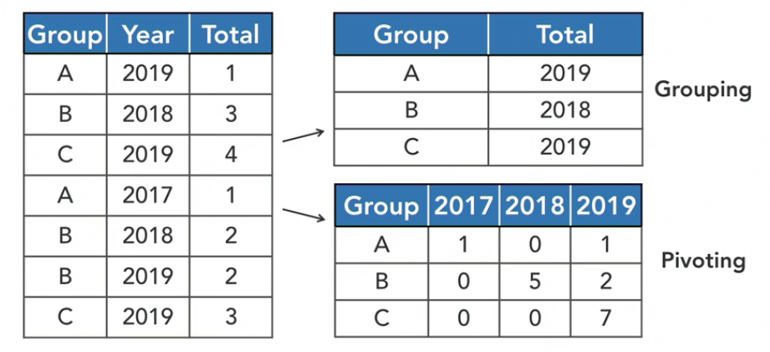

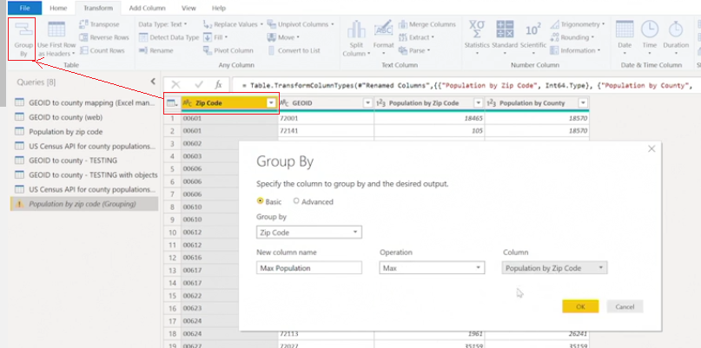

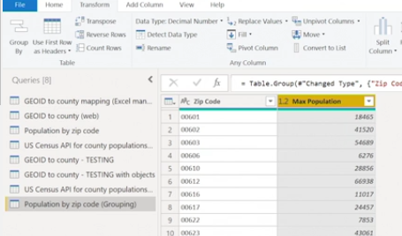

Let's say you have a theoretical data table containing three columns: purchase date, location, and amount. You want to create a new data table that groups the total amount together by the purchase date and location, which are still their own columns. How can you do this using the grouping functionality?

Select the Advanced Options and include both columns as categories to group the aggregated sum of the amounts by.

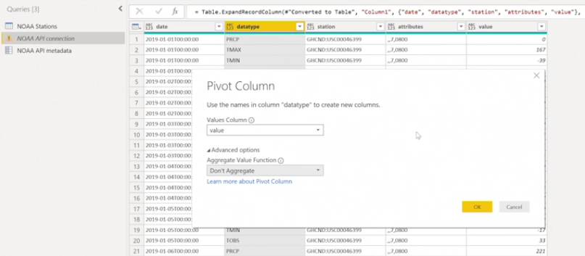

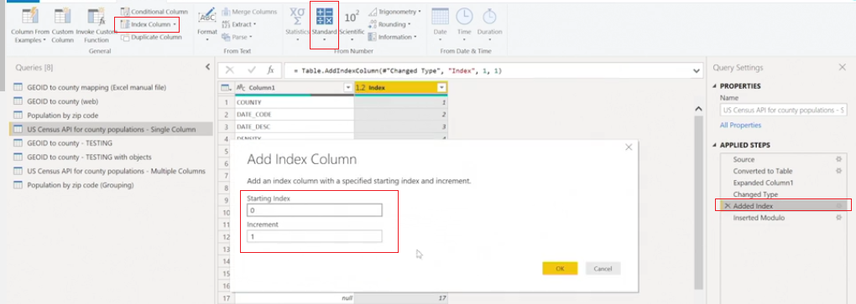

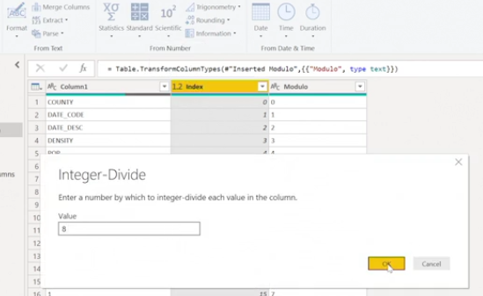

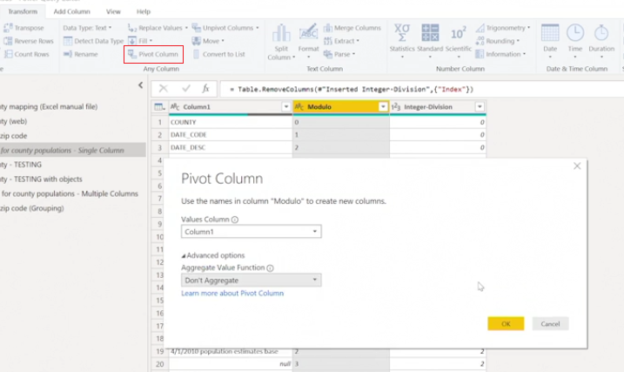

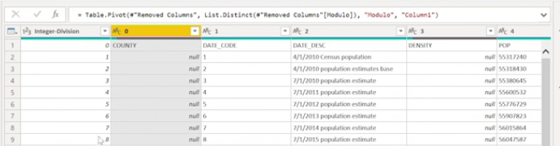

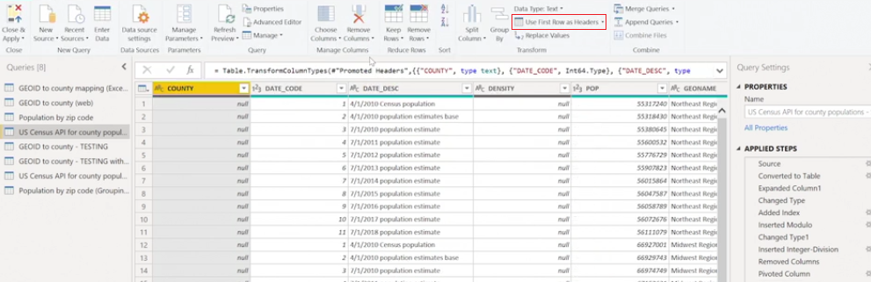

Transpose

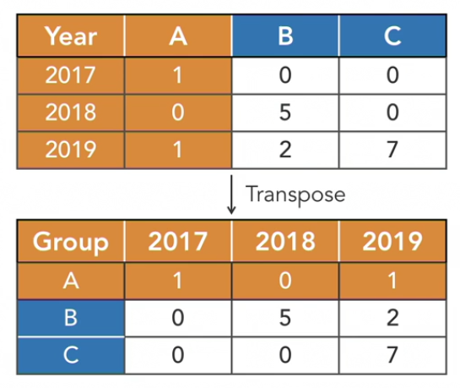

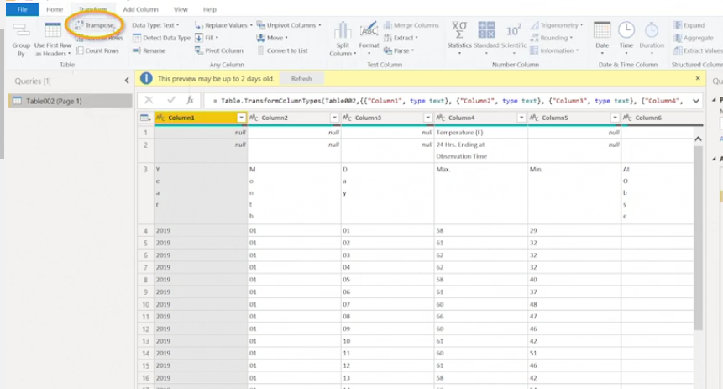

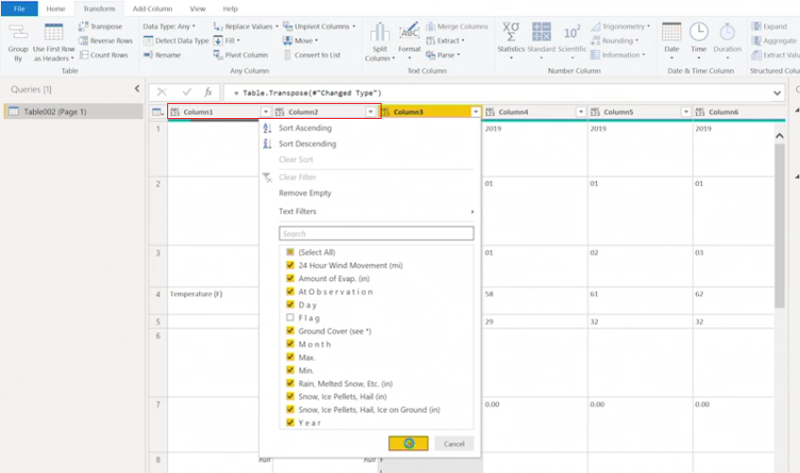

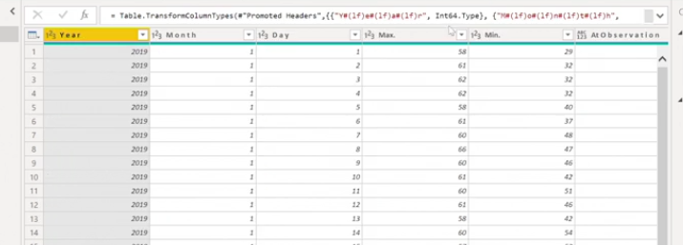

Unpivot

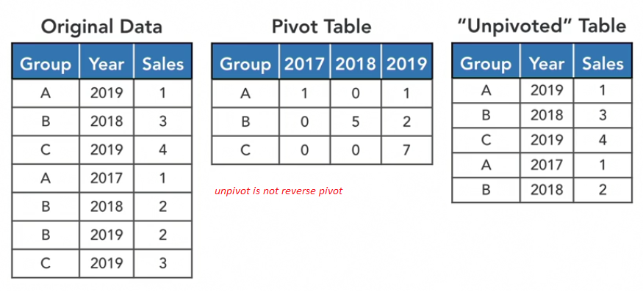

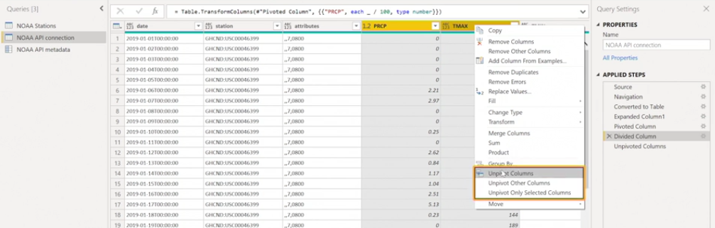

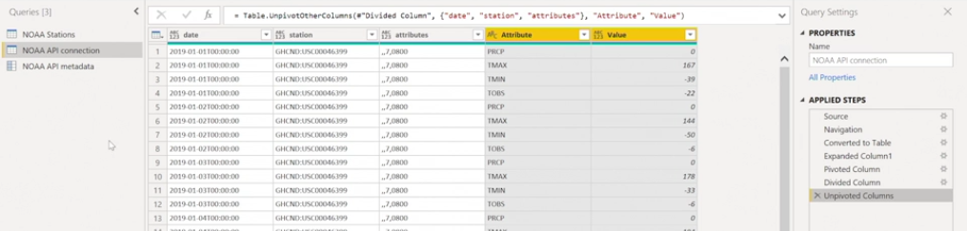

Accessing Native Query - Query folding

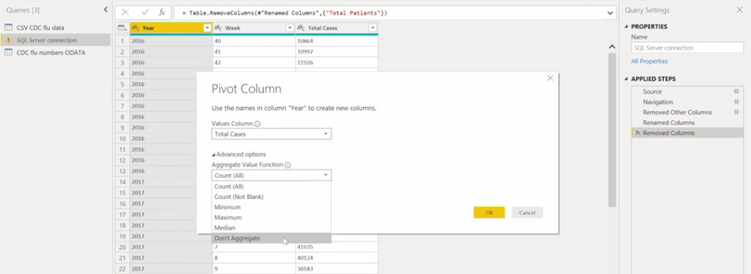

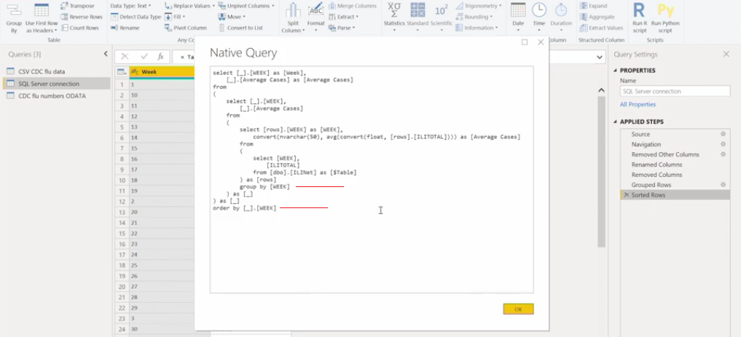

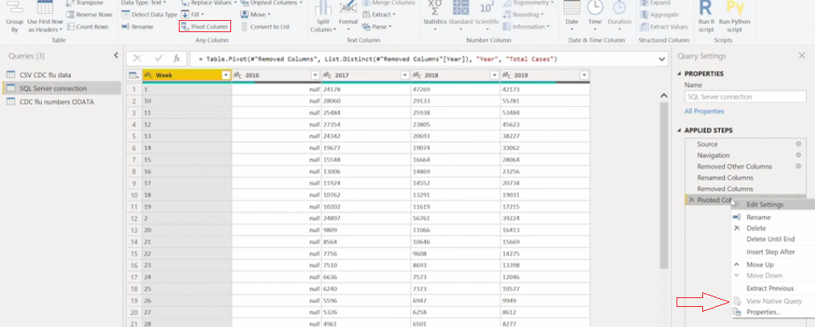

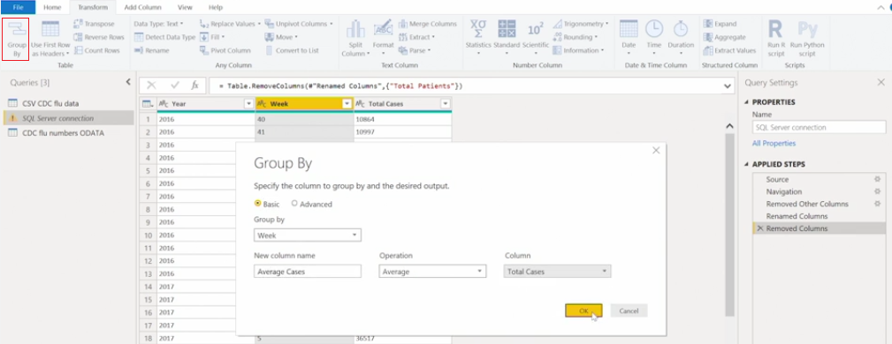

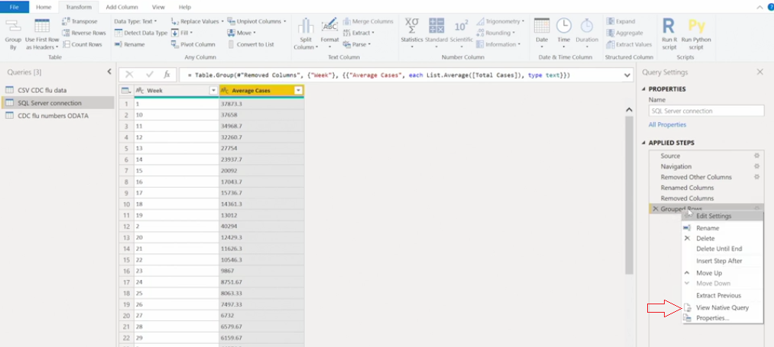

Transforming Data: Enrichment

Leveraging Text Formulas

|  |  |
| --- | --- |
| **Excel Formula** | **Power Query Formula** |
| Not case Sensitive | Case Sensitive |
| Base 1 | Base 0 |
| Implicit Data conversion | Strict Data Type |

|  |  |
| --- | --- |
| **Excel Formula** | **Power Query Formula** |
| LEFT | Text.Start |
| RIGHT | Text.End |
| LEN | Text.Length |
| FIND | Text.PositionOf |
| MID | Text.Range |

Converting Data Types

|  |  |
| --- | --- |
| **Other Types to Text** | **Text to other Types** |
| Date.ToText | Date.FromText |
| Time.ToText | Time.FromText |
| Number.ToText | Duration.FromText |
|  | Number.FromText |

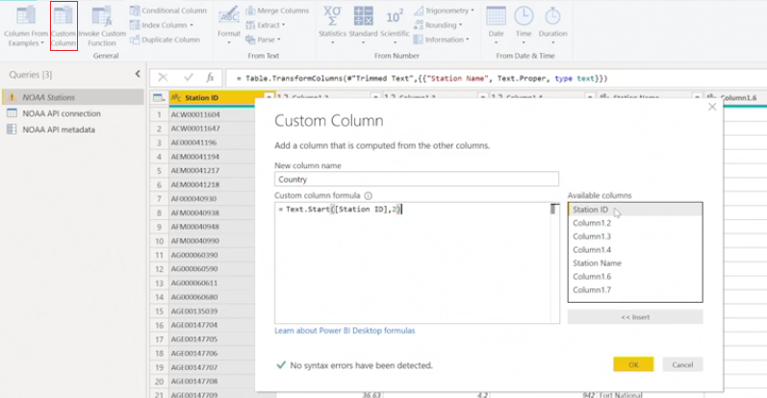

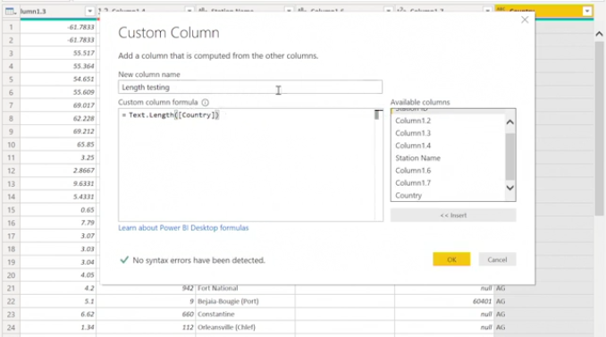

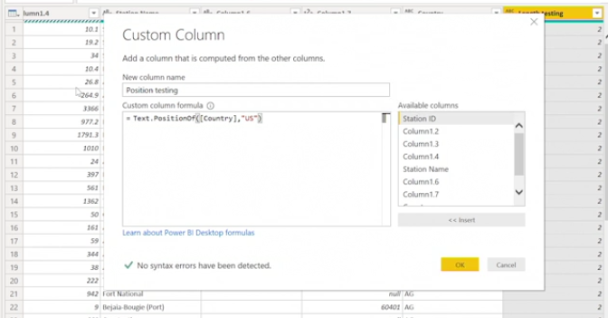

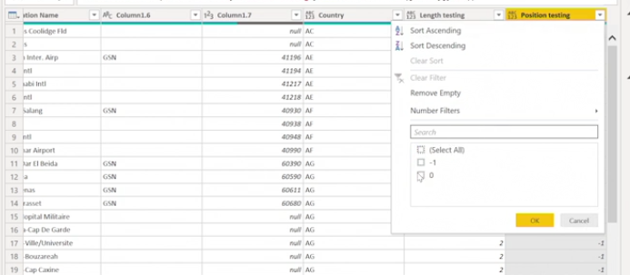

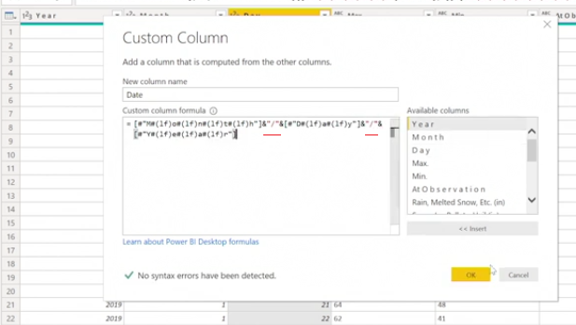

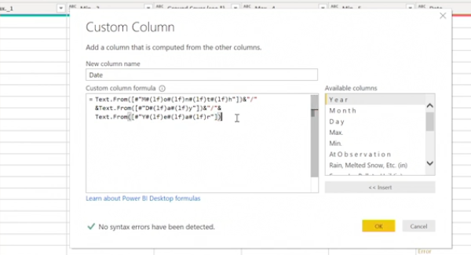

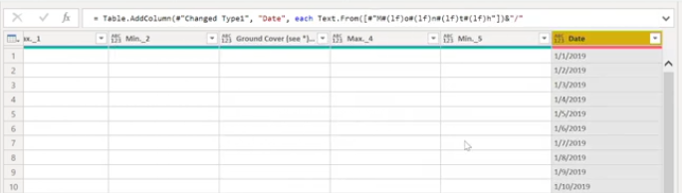

Conditional Functions:

if [Column1] = 1:

then "Result 1"

else if [Column2] = "A":

then "Result 2"

else if [Column3] = "B":

then "Result 3"

...

else [Column 2]

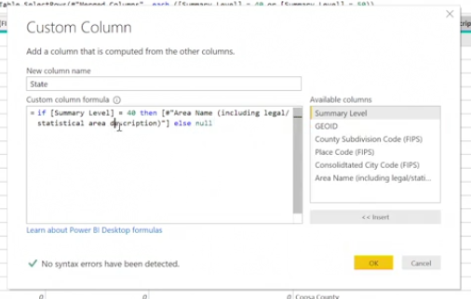

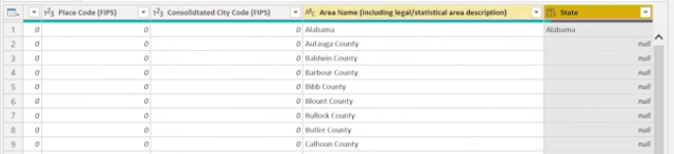

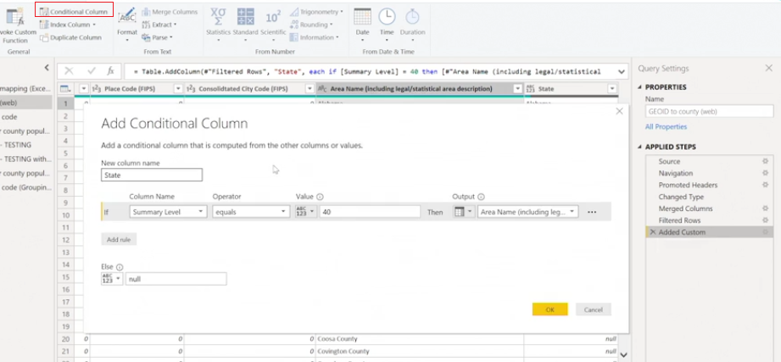

Fill up or Down Columns

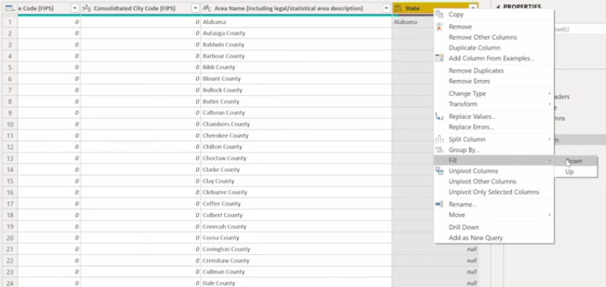

Leveraging Date Formulas

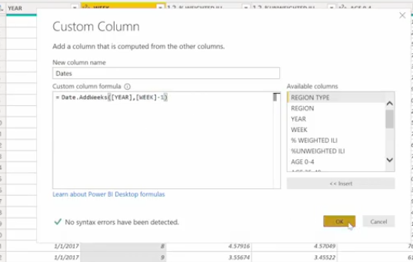

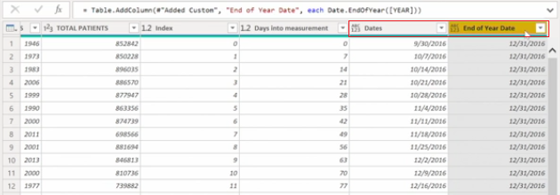

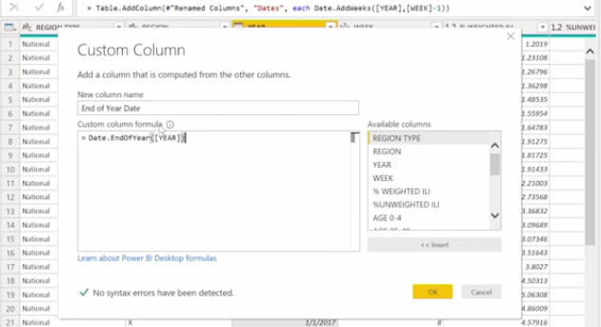

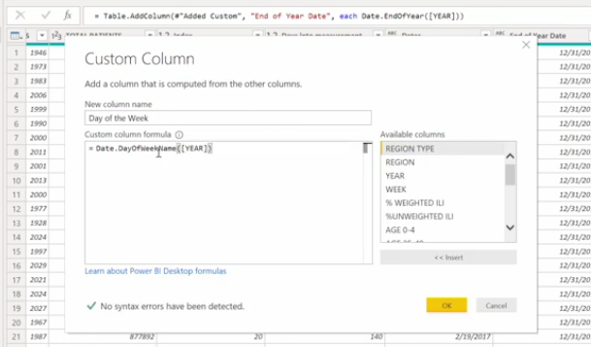

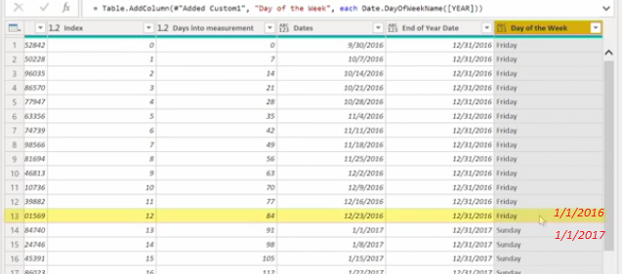

Combining Binary Files with Formulas

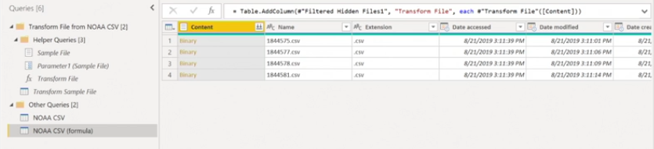

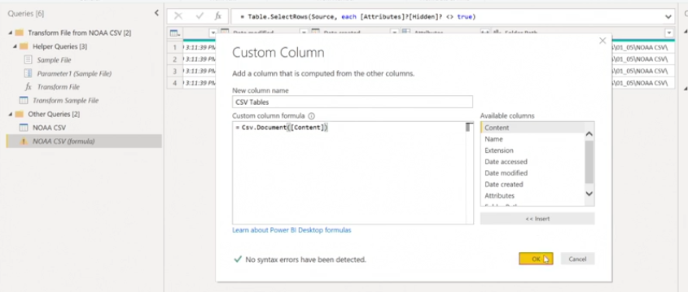

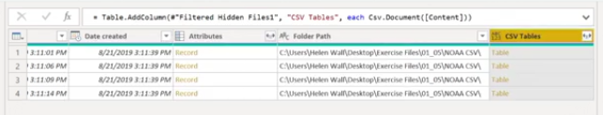

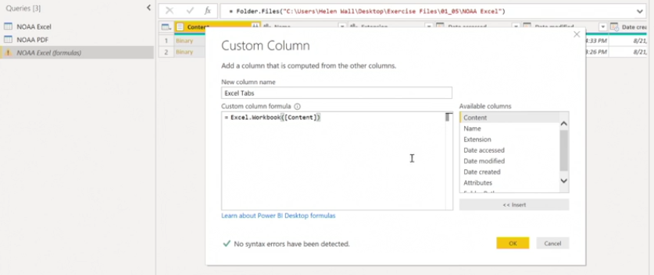

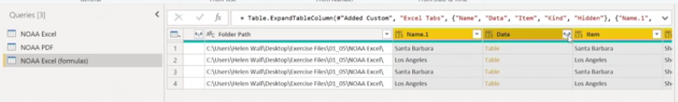

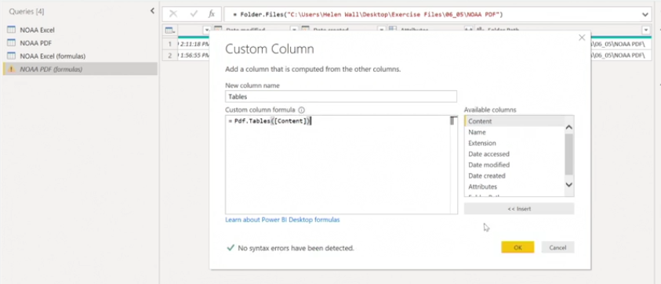

Accessing Native Query in enrichment

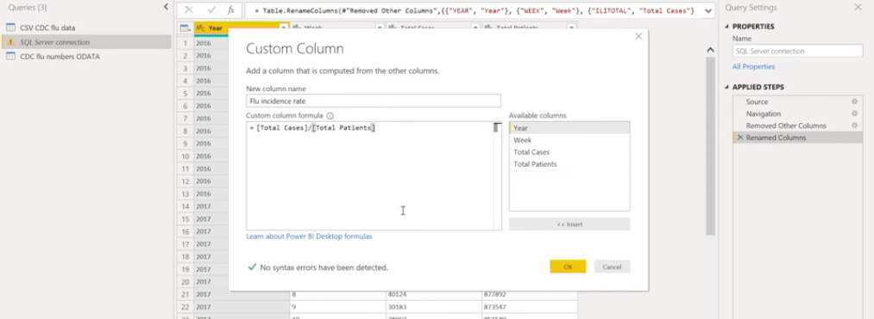

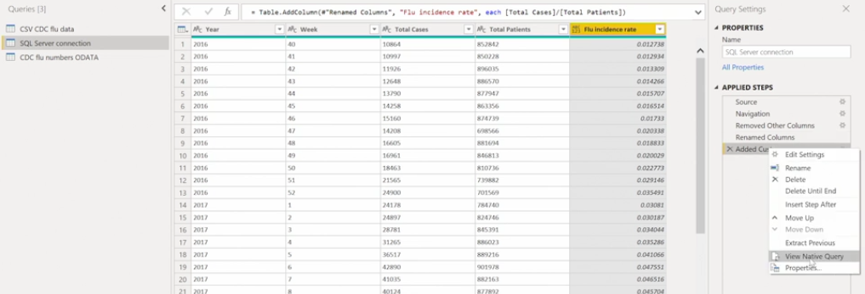

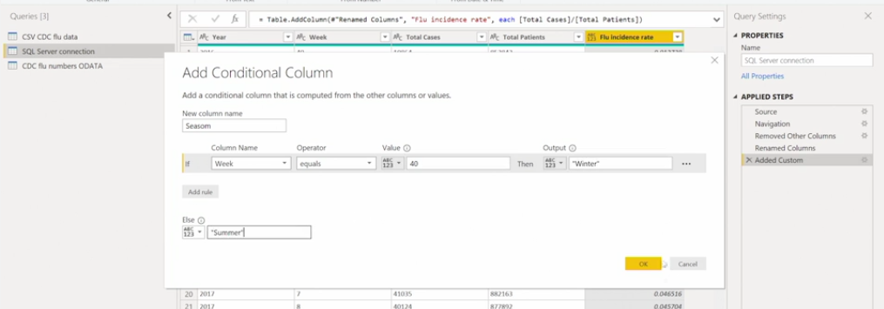

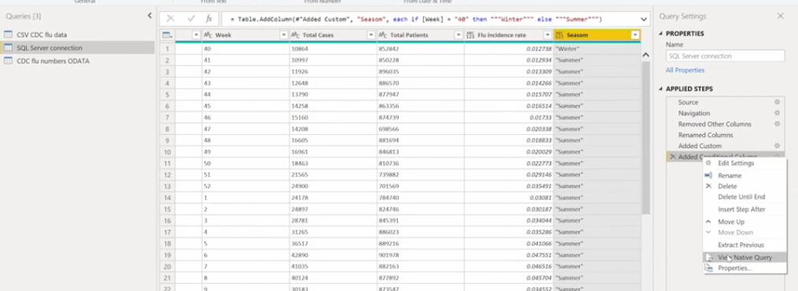

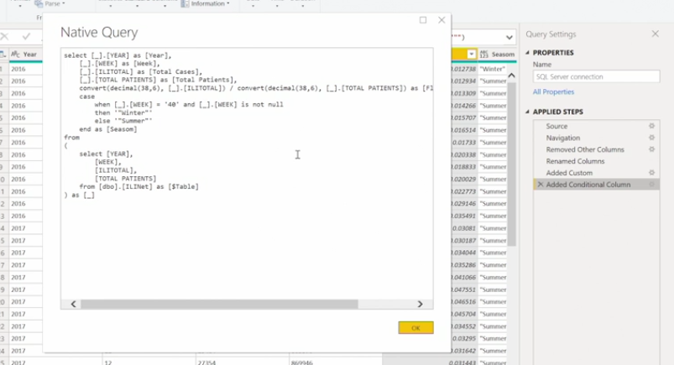

**Someone sent you an entire year of data as 12 months of Excel files with several tabs in them, but you only want one tab from each Excel file. What is the best approach to combine them in the query editor?**

First set up a function to read the tabs within each binary object (the Excel workbooks) as table objects, then combine these table objects into a single dataset.

**If you find that the fill down option does not work as anticipated on the target column, what are some triage options to get it to work?**

Isolate the nulls in either the column to fill down or create a new column to put the values to fill down and the null values in the other rows.

**M Language: Logic and Syntax**

**Query Editor Steps**

Records Extraction and Transformation - steps in power BI with array of functions

Similar to f# language, functional Programming language

Treats computation as mathematical function evaluations

Avoid changing state and mutable data

M has variables-expressions-values

Syntax:

let

var = expression1,

value=1,

#"var name"=expression2 --variable with spaces starts with # and within -> ""

in

variablename

let : sequence of steps

in: output the query returned

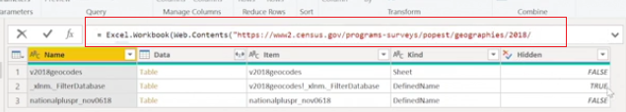

Type of Errors:

* Row level - single value in a column err out
* Step level - error occur when applied errs out for entire query. Ex: Divide text by num

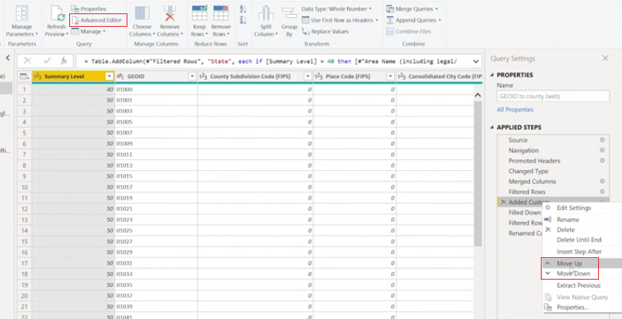

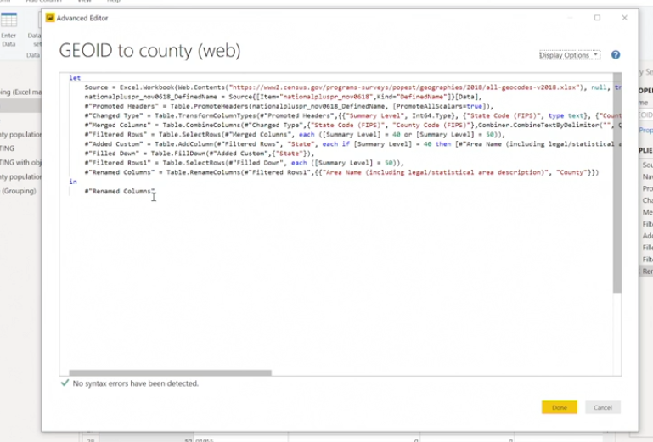

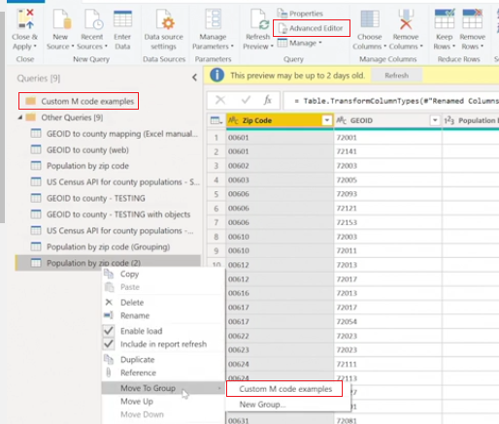

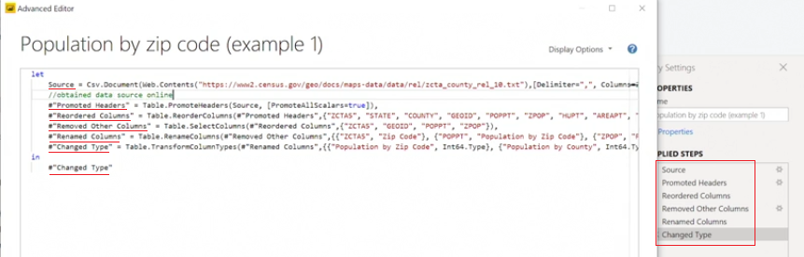

Renaming Syntax

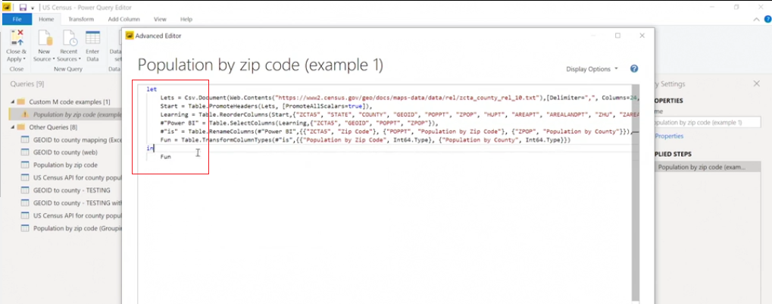

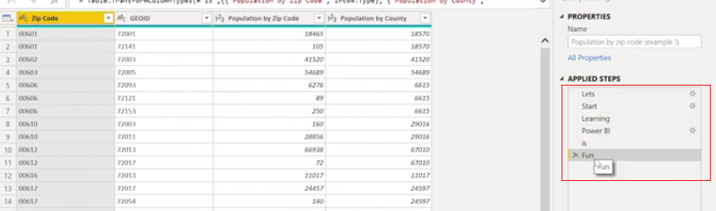

Consolidate M steps

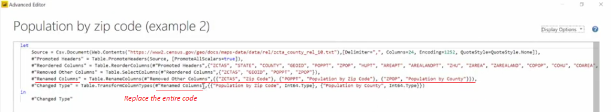

Adding data type as custom M code

|  |  |
| --- | --- |
| **data Type** | **M Syntax** |
| Whole number | Int64.Type |
| Decimal number | Number.Type |
| Dates | Date.Type |
| Text | Text.Type |

Which is NOT a data type that you can insert at the end of a column expression in creating custom M code? **Integer.Type**

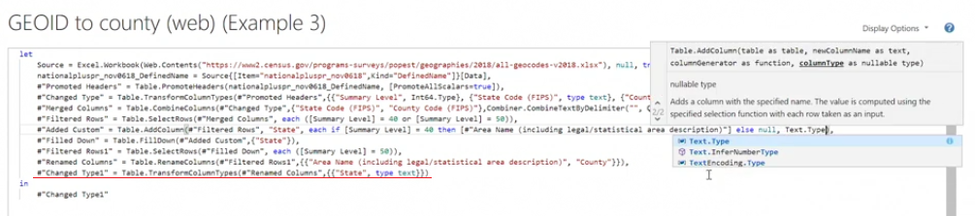

Connecting Zipped Binary file

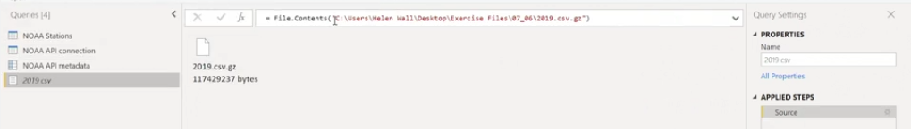

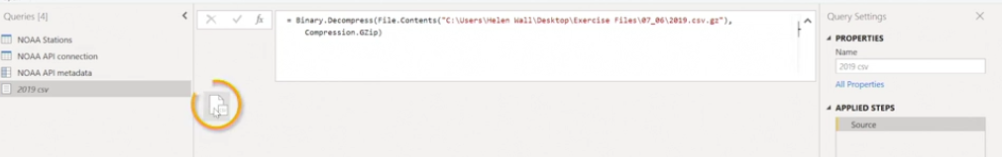

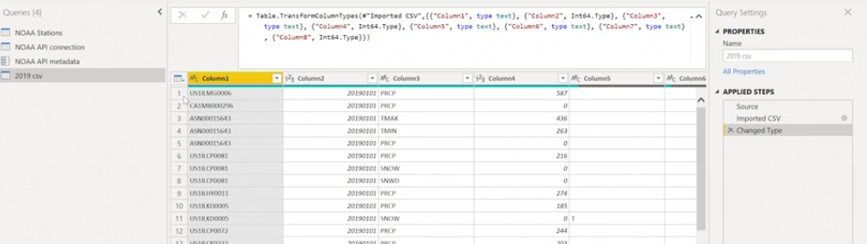

**M Language: objects**

Parameter object

* object can return single self contained value
* minimize reliance on outside files
* Potential use in multiple other queries

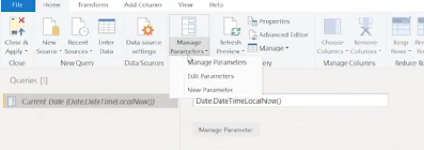

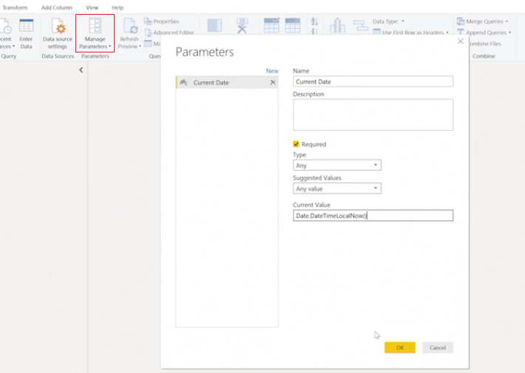

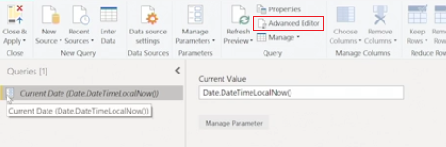

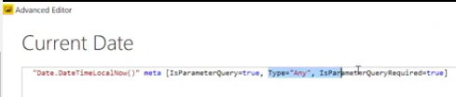

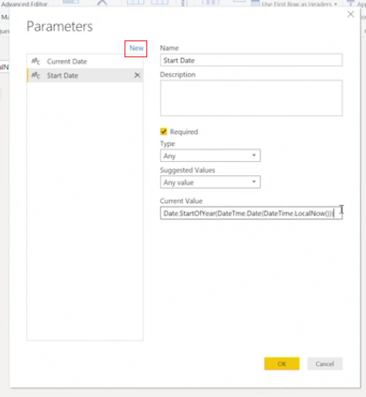

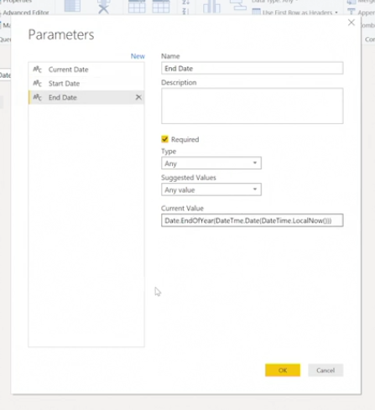

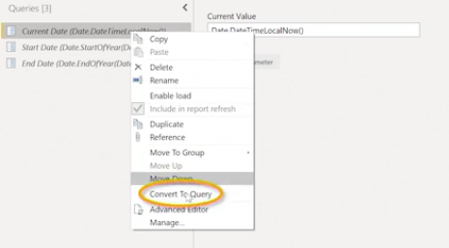

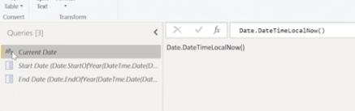

List objects: (Structured values / Ordered sequence values)

- M language classifies lists, records, tables as structured values

|  |  |
| --- | --- |
| **Creating List** | **Converting to List** |
| List.Dates | Binary.ToList |
| List.Numbers | Table.ToList |
| List.Random | Text.ToList |

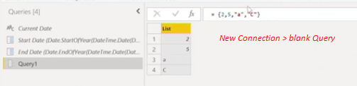

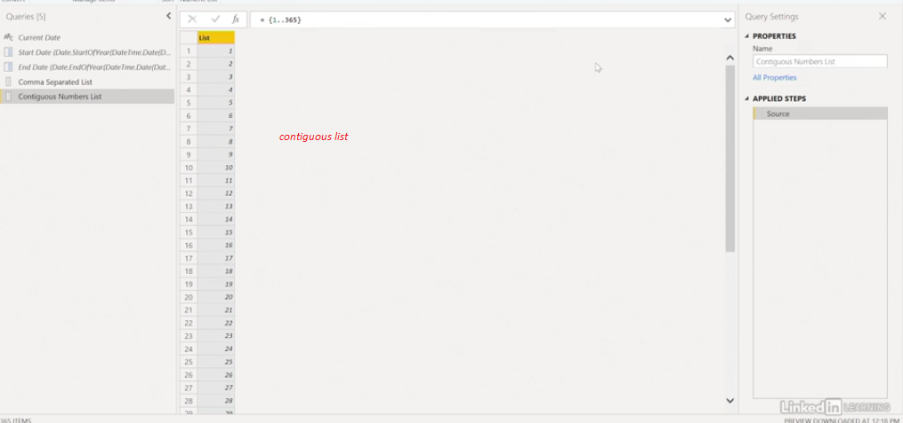

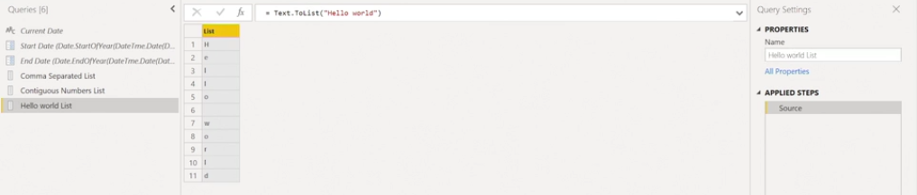

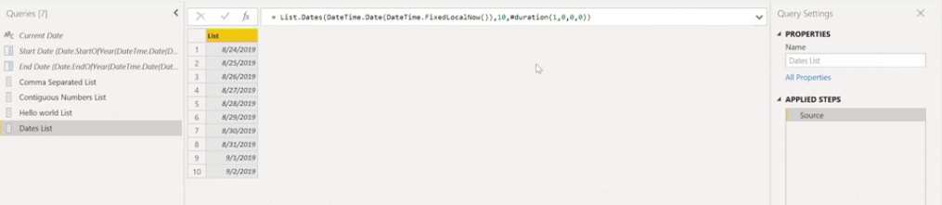

List from table column

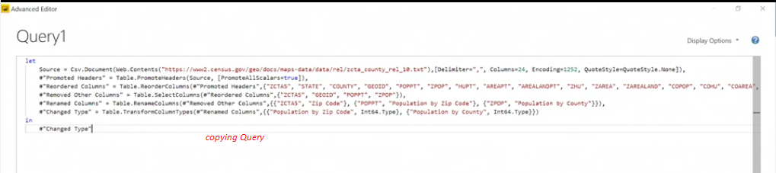

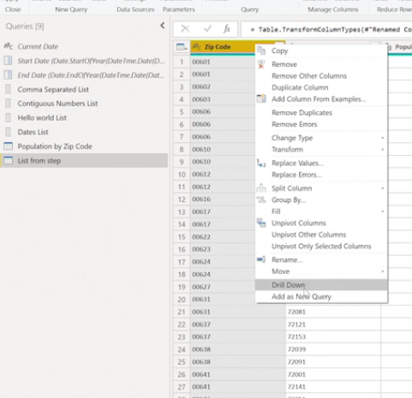

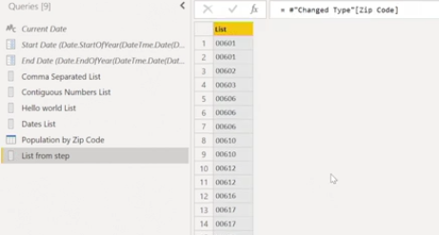

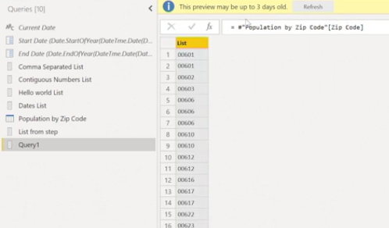

Leveraging Record objects

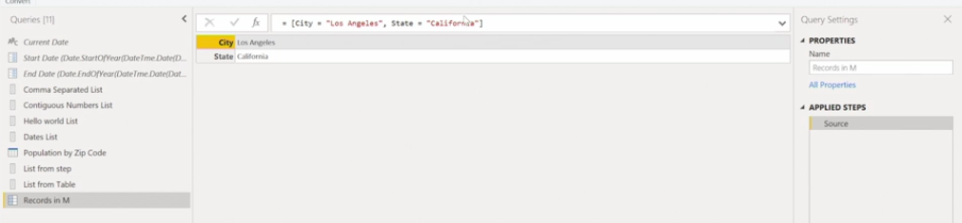

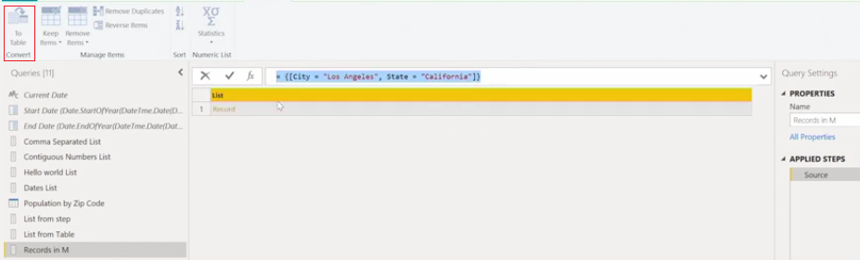

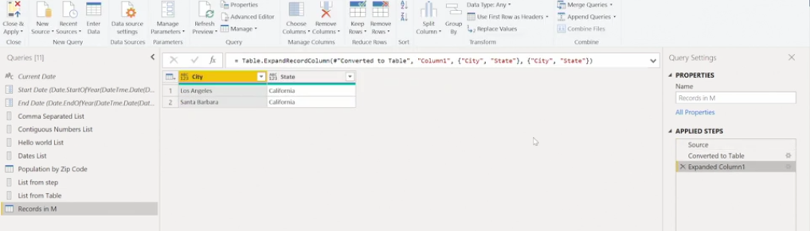

**List functions**

List.Count

List.Min

List.max

List.Sum

List.Average

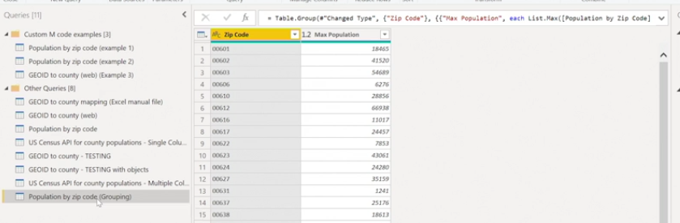

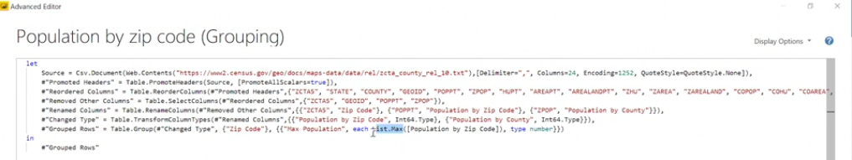

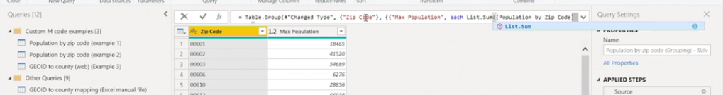

Create date tables

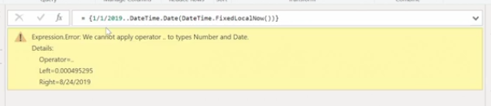

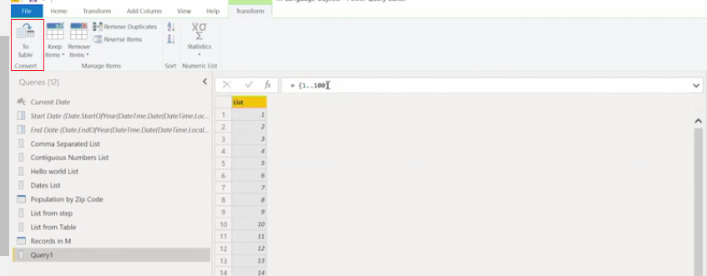

You want to create a list of values of a superstitious elevator from 1 to 12 and then from 14 to 50. How do you set this up using custom M code? **{1..12,14..50}**

What is the outcome of the function List.Unique{1,2,1,2,"a","A","b","C"}? **{1,2,"a","A","b","C"}**

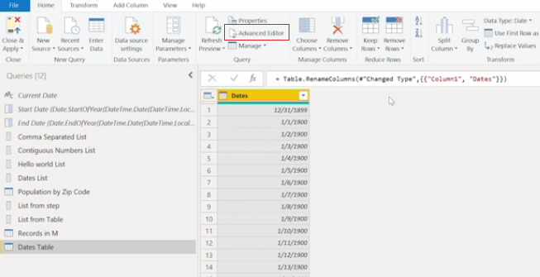

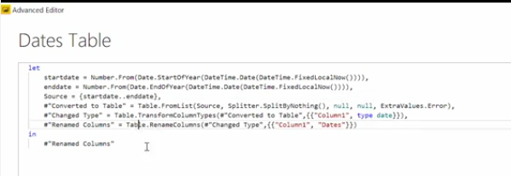

Looping with Lists

List.Generate : new list using loop logic

List.Sort : Sorts list into numerical order

List.Combine : create new list from two or more lists

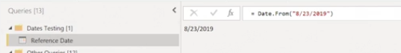

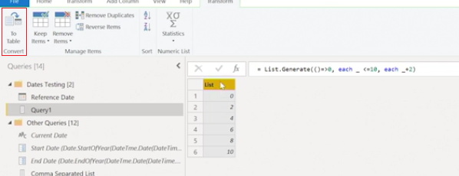

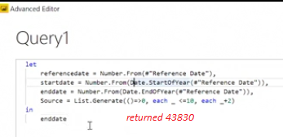

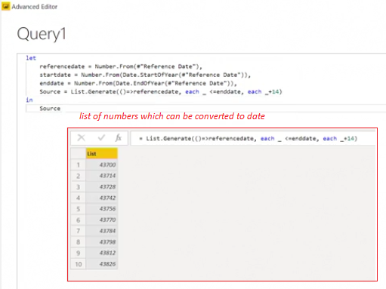

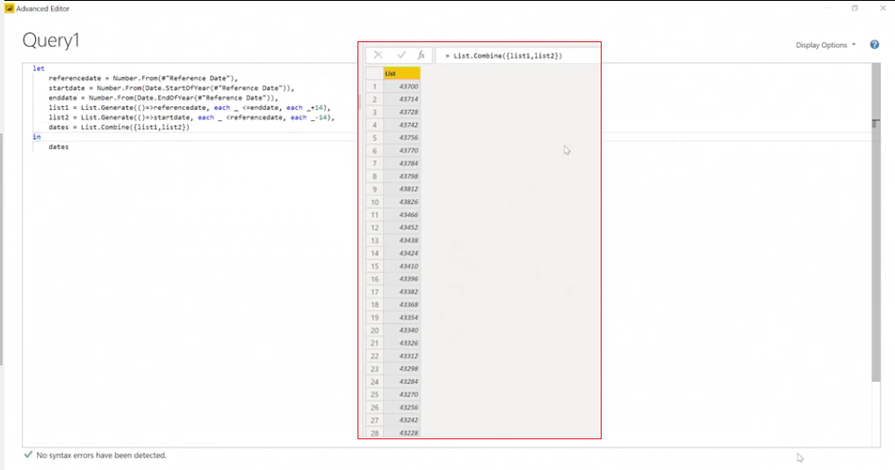

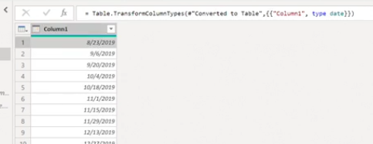

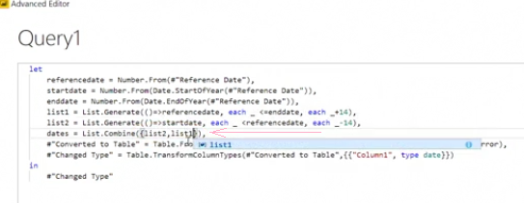

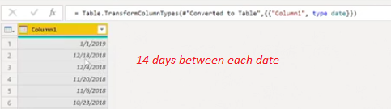

Combining List Objects

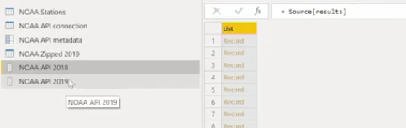

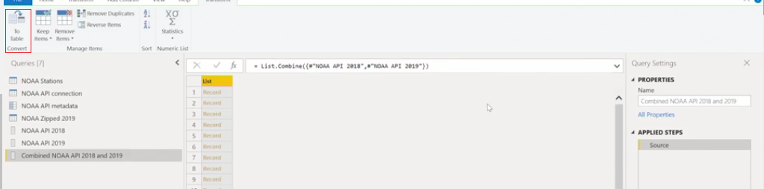

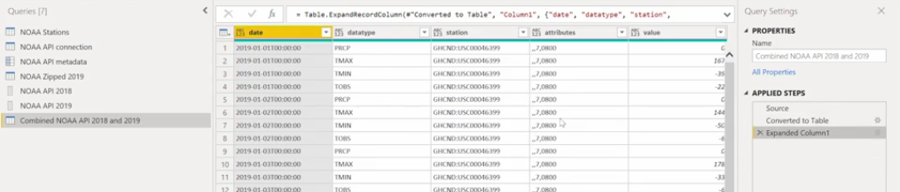

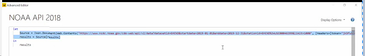

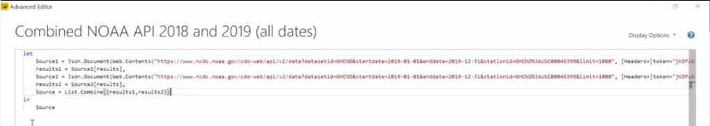

**Leveraging M language: Custom Functions**

Create Custom functions:

1. Name function parameters
2. Create calculation expression to return result

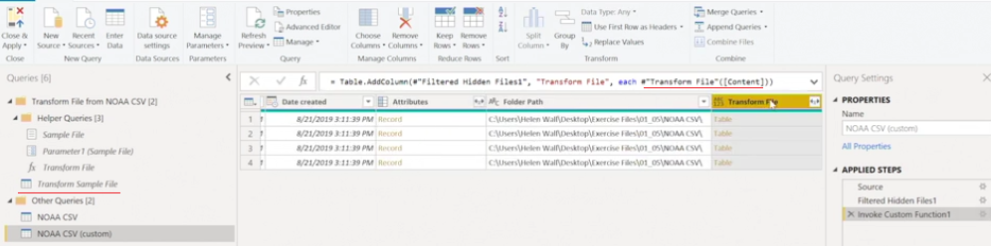

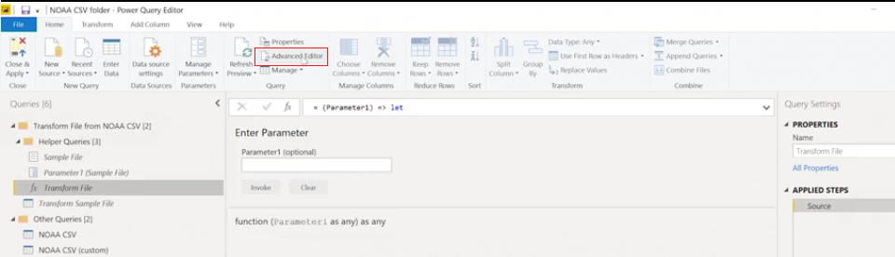

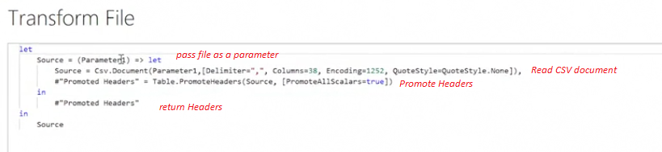

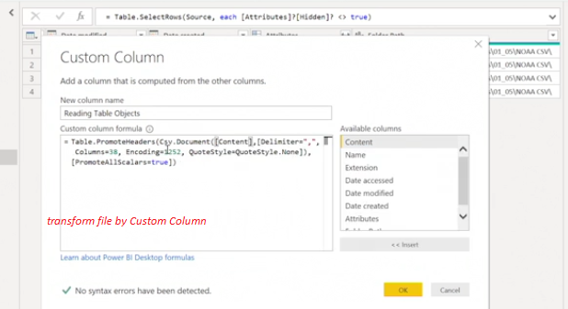

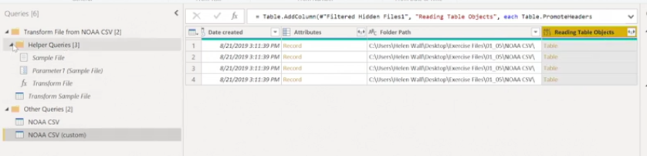

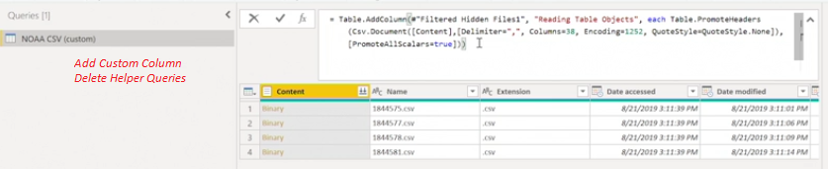

Converting Queries into Functions

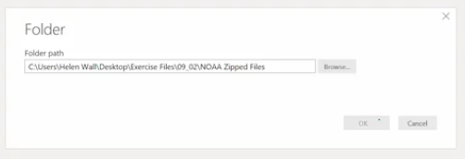

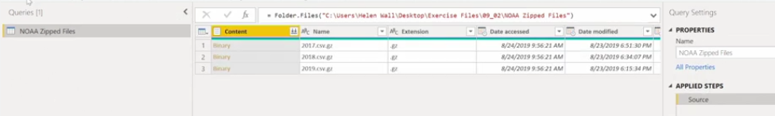

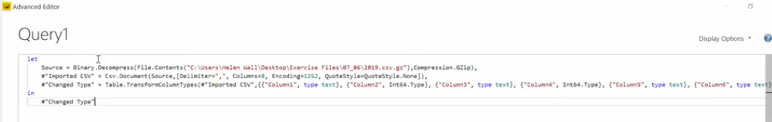

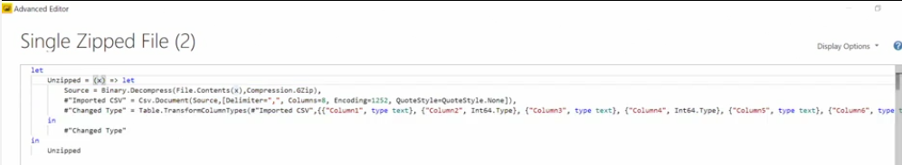

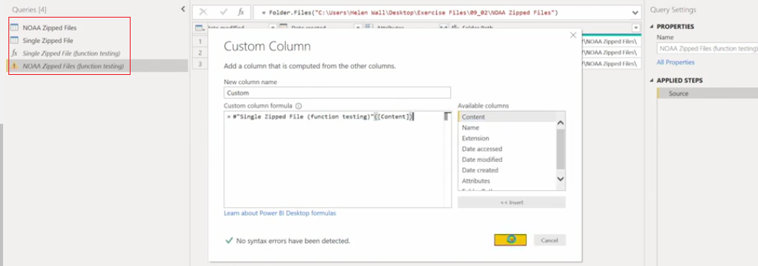

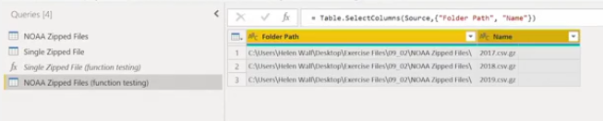

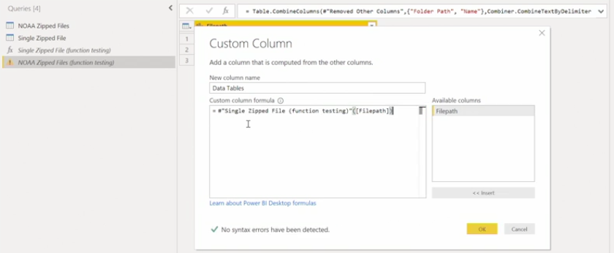

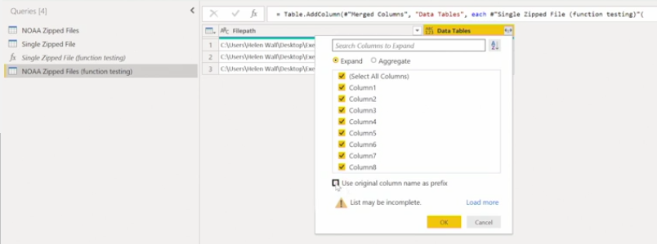

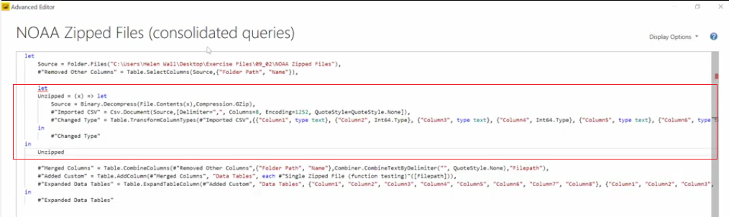

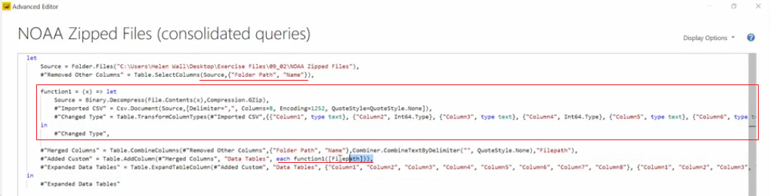

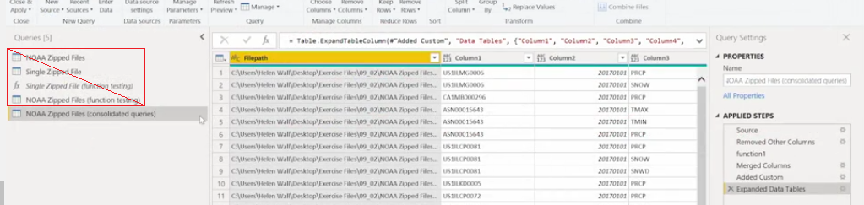

Configuring Custom filtering

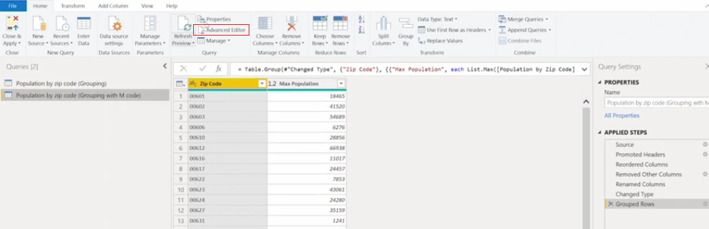

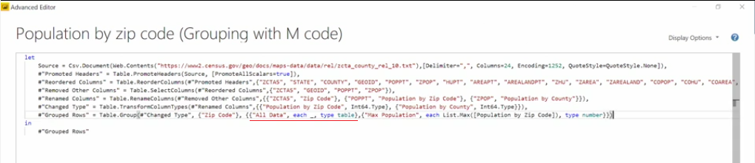

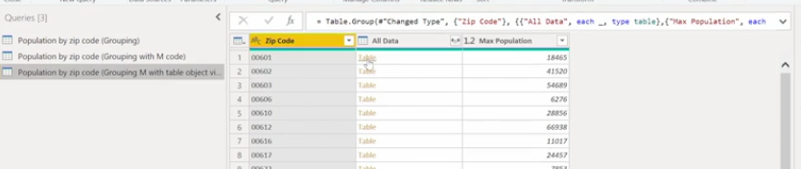

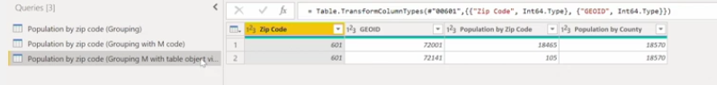

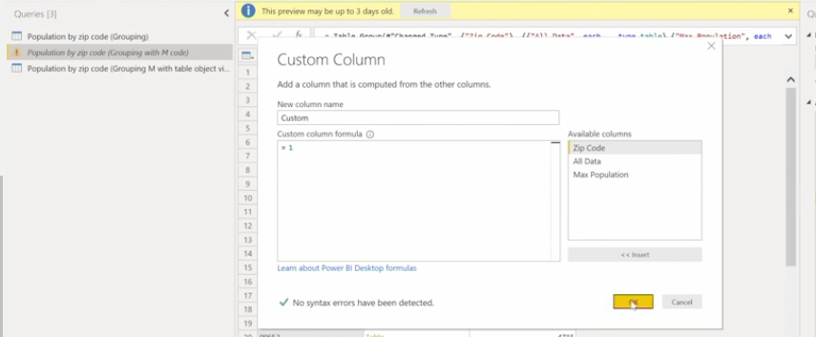

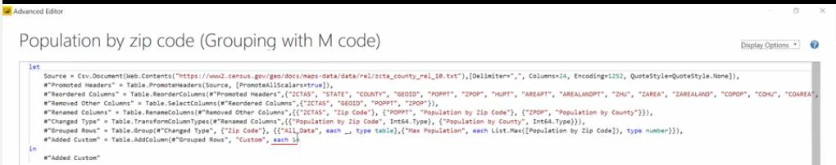

Setting up custom filtering can involve starting with the Power Query M function that allows you to filter tables, which is represented in which function expression? **Table.SelectRows**

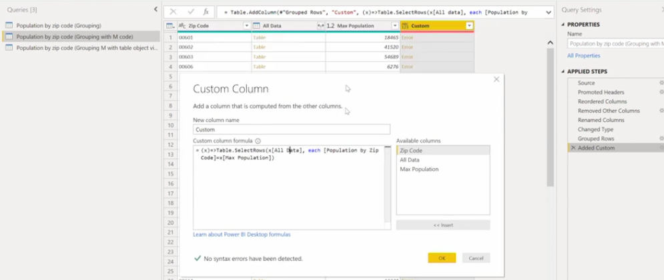

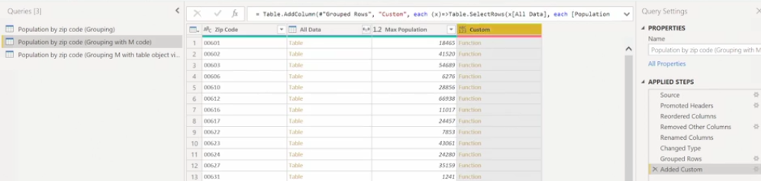

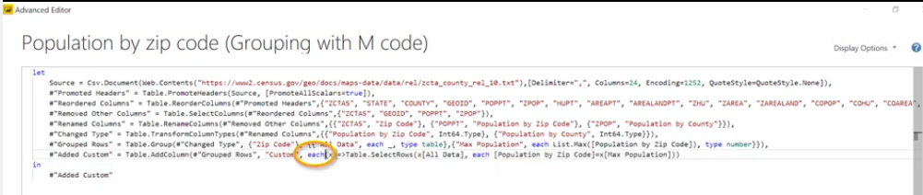

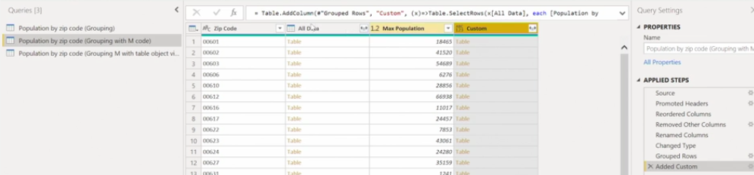

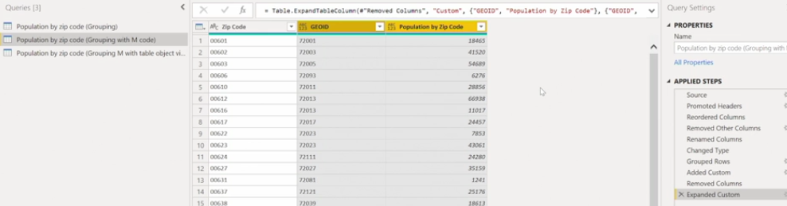

**Loading Data**

Configuring Loading option

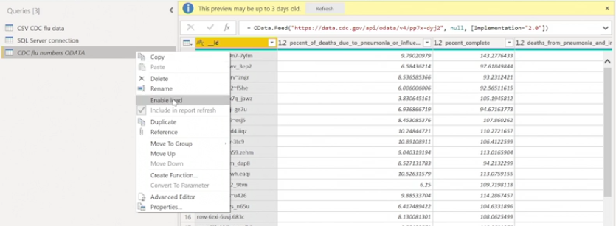

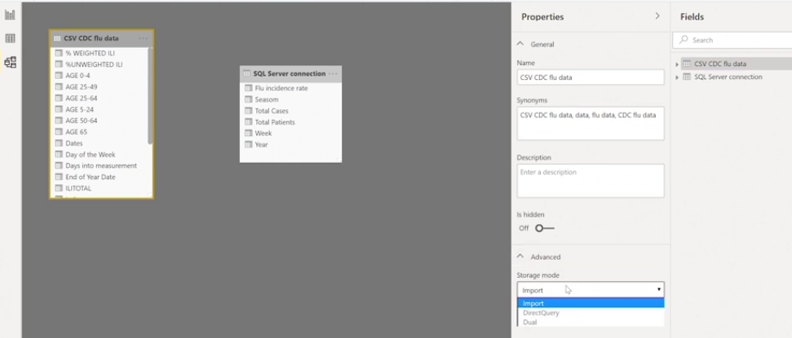

Errors after loading

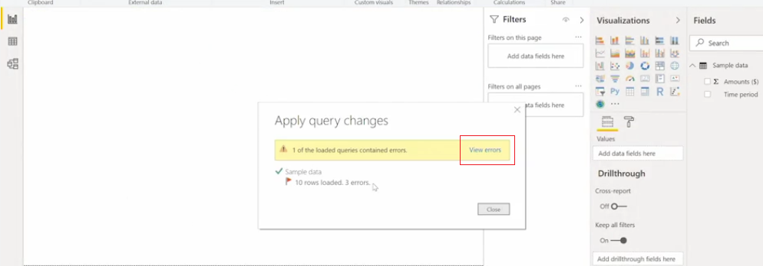

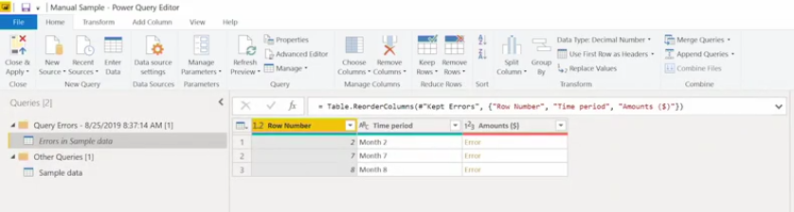

Refresh Data - Schedule refresh

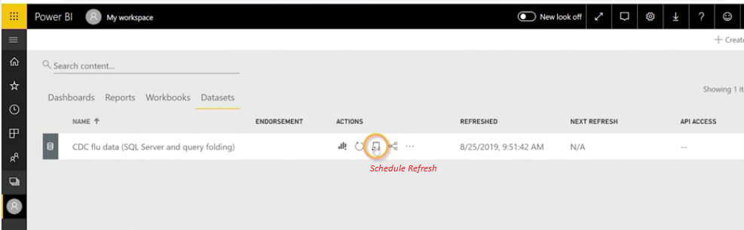

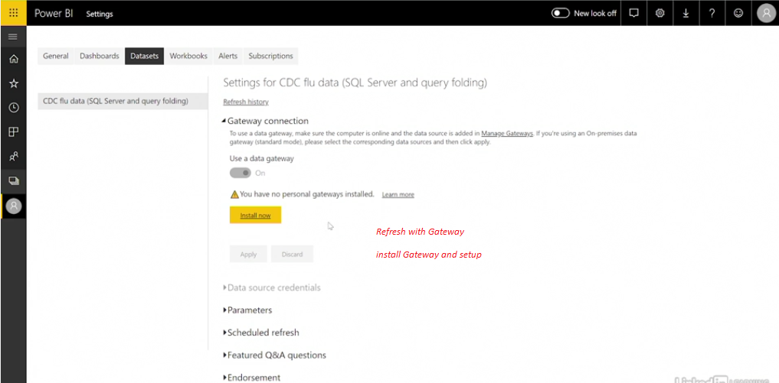

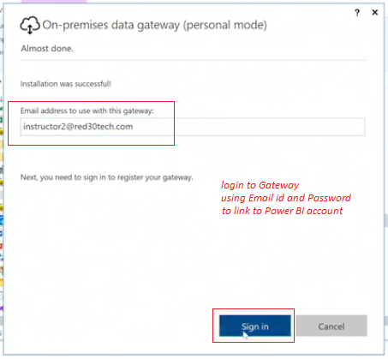

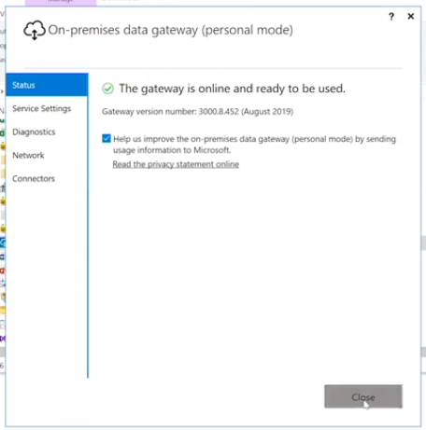

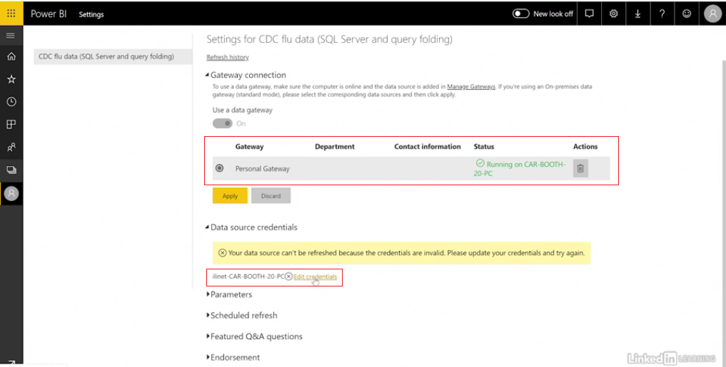

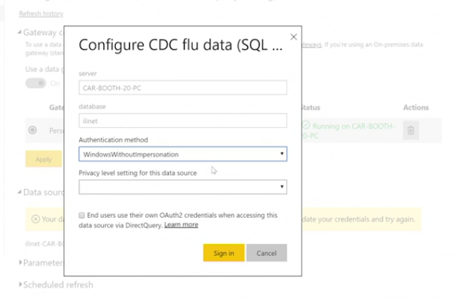

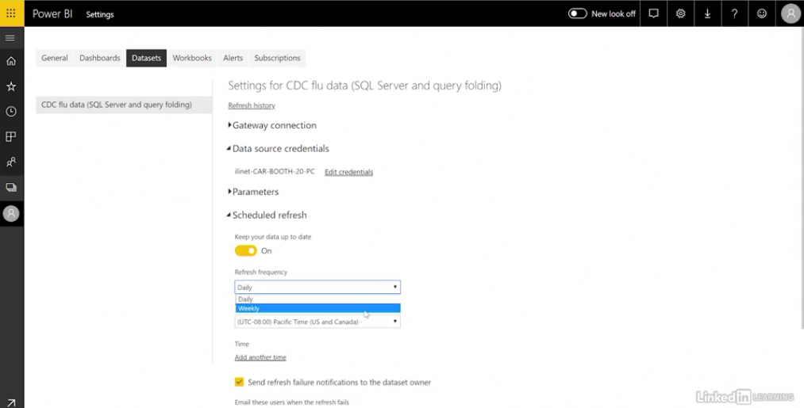

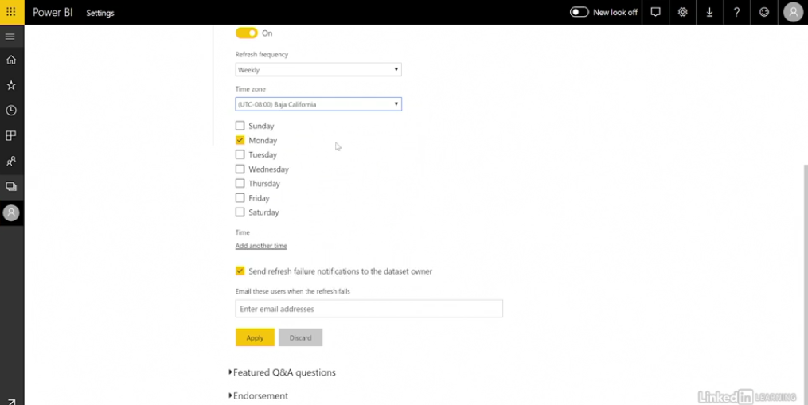

Joining Sets of data

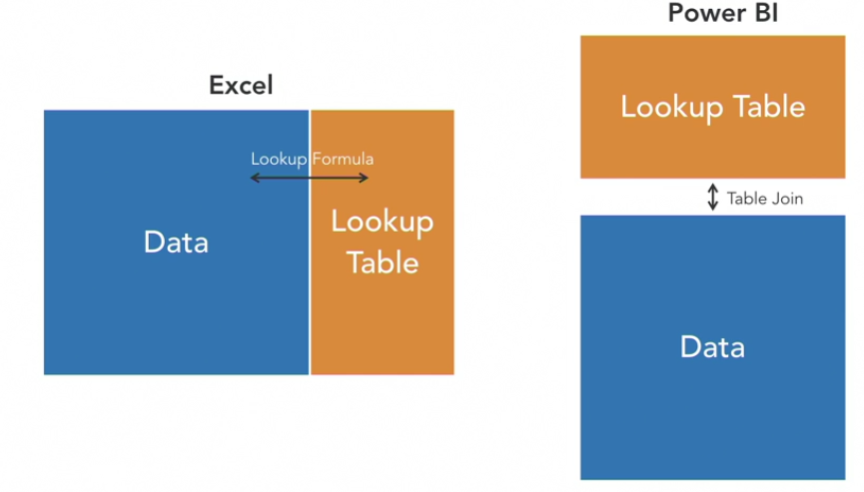

Relationships:

Many-to-one: between data tables and lookup key

Many-to-Many: allow us to join together or aggregate two or more tables

